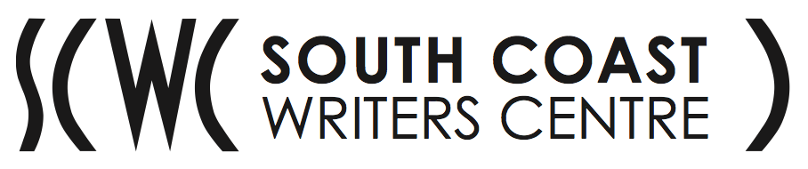

Ngana Barangarai (Black Wallaby) Aboriginal & Torres Strait Islander Literary Program Co-ordinator at the South Coast Writers Centre

Position Responsibilities and Selection Criteria

RESPONSIBILITIES

- Work with the SCWC Director and the Ngana Barangarai Project Leader in support of the Centre’s vision and goals
- Co-ordinate the current Ngana Barangarai program
- Work closely with the Office Manager to budget and manage the Ngana Barangarai program’s resources, including funding applications and acquittals
- Identify and apply for funding towards writing workshops at Junee Correctional Centre (two per year) and to cover costs associated with the compilation, publication and printing of the annual Dreaming Inside anthology, and organise the Ngana Barangarai Writers Night.
- Work closely with Ngana Barangarai Program Leader to co-ordinate the Aboriginal Consultation Team, and prepare reports for Committee of Management meetings and for other occasions as required
- Negotiate with and engage casual tutors and professional writers for the program as required
- Represent the South Coast Writers' Centre, and Ngana Barangarai literary programs in particular within the arts, cultural and education community
- Oversee training and management of interns/volunteers working on Ngana Barangarai literary program
- Prioritise the demands of the position and manage competing tasks.

SELECTION CRITERIA

- Qualifications and/or experience in arts or community management or similar field
- A demonstrated track record of securing funding and delivering projects within budget and on time, and knowledge of the attendant reporting requirements
- Excellent communication skills, both written and oral
- Well-developed administration, organisational and self-management skills
- Proficiency in general computer skills including word processing and email, and excellent attention to detail
- Experience working with Aboriginal & Torres Strait Islander people, organisations and networks, and a robust network within this sector
- Demonstrated experience in community cultural development
- Flexible attitude to responsibilities and working hours
- Knowledge of WH&S, Equal Opportunity and other related legislation

Applications are due before 5pm Tuesday 24th September 2019
Interviews are expected to be conducted on Friday 11th October 2019

Please send your application addressing ALL selection criteria by email to director@southcoastwriters.org.au.

Any queries please contact the South Coast Writers Centre Director, Kirstin Bokor, by email at director@southcoastwriters.org.au or telephone on (02) 4228 0151.

