Role Particulars
Position Title: Environmental Educator | Location: Sydney
Level: 2 | Team: Marketing and Customer
Reports to: Head of Marketing & Customer | Supervises: N/A
Hours: Casual | Status: Casual
About Australian Energy Foundation (AEF)
The Australian Energy Foundation is leading the way to an equitable zero carbon society. We accelerate the energy transition by empowering communities to take action.

Through our energy expertise, tenacity, and partnerships, we:
- Demonstrate the pathways to a zero carbon society.
- Influence and inspire to build understanding, investment and action.
- Deliver solutions that have a positive impact.

We are practical visionaries; a national for-purpose organisation whose work benefits all Australians.

Organisational Structure
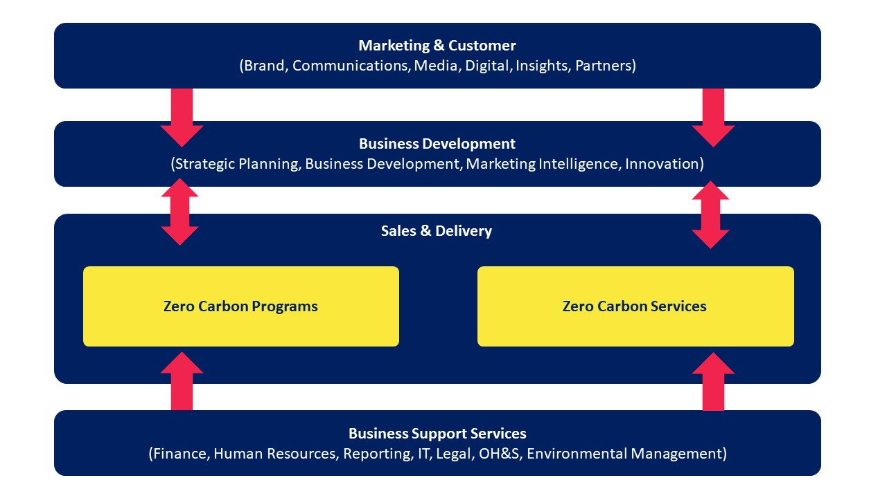
Purpose of Position
The purpose of this position is to deliver a series of public information sessions related to energy-efficiency and renewable energy. This role will involve travelling to various venues across Sydney, setting up the venue, presenting the workshop to large groups and following up with attendees post event. This position will require you to stay up to date on the latest information and trends related to energy-efficiency and renewable energy.

Key Responsibilities of Position
Working closely with the Marketing & Customer team, responsibilities of the role include:

Effectively delivering energy-efficiency and renewable energy workshops
- Presenting the workshop to large groups, ranging from 30 to 200 people
- Communicating complex topics in an easy to understand and engaging manner
- Clearly and effectively answering the audience’s questions
- Staying up to date with the latest trends on renewable energy and energy-efficiency
- Ensuring you adhere to the Australian Energy Foundation’s messaging, not your own personal point of view
- Conducting yourself in a professional manner, including handling possibly difficult members of the public.

Assisting in organising the workshop
- Helping Council staff with set-up and pack down of venue
- Printing out registration list
- Tracking event attendees
- Supporting attendees that would like to request a quote from one of AEF’s suppliers

Following up with attendees post-event
- Setting up evaluation surveys
- Reporting of attendees and number of quotes requested
- Following up with attendees via email
- Data entry into AEF’s CRM

Any other duties that may arise from time to time which fall within the parameters of this position and within the level of skills, competencies and training expected of the person filling this position may also become responsibilities or become performance indicators.

Relationships
Internal:
You will be regularly liaising with the Marketing & Customer and Zero Carbon Services teams.

External:
This role is community-facing. As such, you will the public face of the Australian Energy Foundation to our Council partners and the general public.

Accountability and extent of authority
- This role has no budget responsibilities.
- You will be accountable for delivering high-quality information sessions that adhere to the Australian Energy Foundation’s messaging.
- You will also be accountable for ensuring all leads are accurately processed into our customer relationship management system.

Mandatory Responsibilities for all Positions
- Comply with all AEF’s policies and procedures
- Comply with established standards, procedures & practices applicable to the position
- Comply with all AEF Workplace Health &Safety (WH&S) directions
- Assist in the resolution of health and safety issues as required.
- Contribute to successful implementation of WH&S programs and initiatives
- Complete the WH&S safety and compliance training required for the position
- Participate in WH&S training and discussions, emergency response exercises, workplace inspections and audits

Behave according to AEF’s values which underpin our efforts to build an organisation based on positive relationships with colleagues and the community:
Innovation • Honesty • Respect • Resilience • Teamwork •
Technical and Professional Capabilities required for the Position
Capabilities
- Presentation and Facilitation Skills
- Effective interpersonal skills
- Influencing
- Relationship Management
- Product and Industry Knowledge

Knowledge
- You must possess strong knowledge in renewable energy and energy-efficiency technologies
- Basic computer software (Word, Excel, Outlook) and capacity to learn quickly
- Proficiency in the use of general office equipment.
- Experience with using Customer Relationship Management (CRM) systems
- Knowledge of strata approval process (Desirable but not essential)

Education, Experience and Certification Required of Position Holder
Education
- A degree in renewable energy or energy efficiency would be beneficial

Experience
- Effective facilitation and presenting to large groups.

Key Challenges and Complexities of Position
The key challenges of this role include:
- AEF is a Not for Profit with limited resources and so a ‘hands-on’ approach is often needed.
- Managing the perception in the marketplace that as a not for profit we should deliver services for free or at a heavily discounted price for all customers with a shared mission.
- Managing the depth and breadth of stakeholders
- Ability to deal with challenging members of the public
- Staying up to date with renewable energy and energy-efficiency

Key Selection Criteria
- Excellent communication skills (written and verbal) including the ability to adapt communications to identified audience and discuss complex concepts in easy English.
- Demonstrated experience in presenting to and facilitating large groups.
- Strong organisational skills with the ability to multitask.
- Experience using software including Microsoft Office and Customer Relationship Management (CRM) systems.
- Demonstrated understanding of energy-efficiency and renewable energy
- Experience in developing and managing evaluation surveys to get valuable data

