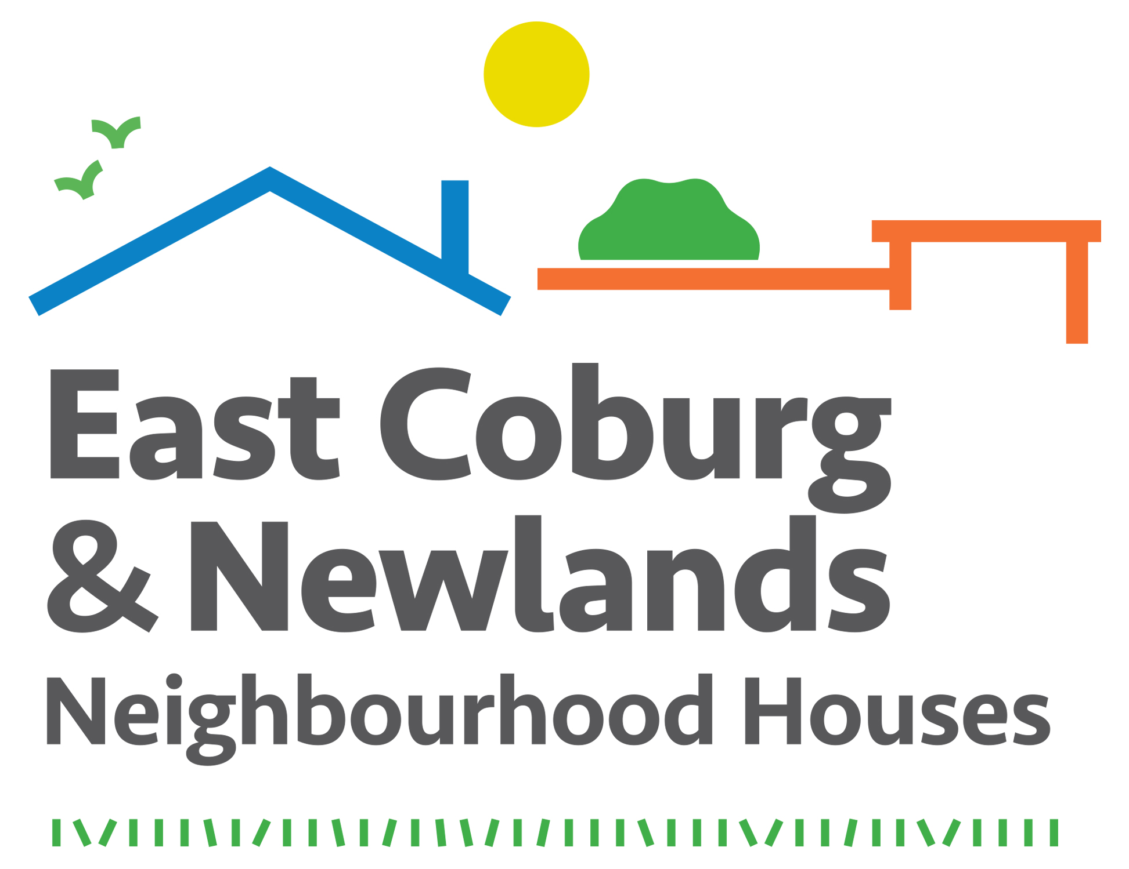

Newlands and East Coburg Community Hubs Inc. (NECCHi)

Position description: Assistant Manager. 12 month contract.

Reporting to: Manager

Background

The Newlands and East Coburg Community Hub is comprised of two Neighbourhood Houses, approximately 10 minutes drive apart. The Newlands house is located at 22 Murray Rd, Coburg North, and the East Coburg house is located at 32 Nicholson St, East Coburg.

The purpose of the Newlands and East Coburg Community Hub is to strengthen the community through creating a space of belonging, inclusivity, equity and growth within a community development framework.

The Assistant Manager is a new position, a 12 month contract with potential for ongoing employment at the end of the contract. In consultation and collaboration with the Manager, the Assistant Manager is to realise the purpose of the Newlands and East Coburg Community Hub.

The amount of time the Assistant Manager will spend at either Newlands Neighbourhood House and East Coburg Neighbourhood House will vary and be dependant on requirements. It is expected that the assistant manager will cover the program coordinators role in their absence.

The organisation is funded by Department of Health and Human Services (DHHS) - through the Neighbourhood House Coordination Program and by Moreland City Council, with additional revenue raised through grants, fundraising activities and programs.

Responsibilities

In consultation with the Manager the role will emcompass the following:

Community development

- Strengthen and enhance effective communication and partnerships with a range of community stakeholders, including residents and other community agencies.
- Seek out, encourage and resource community, group and individual initiatives which are consistent with the organisation’s constitution, purpose, strategic plan, and business plan.
- Develop and implement processes that foster the ongoing engagement of the community.

Leadership

- Lead, in conjunction with the manager, the organisation in its aim to strengthen the community through innovative strategies, programs and approaches that identify and meet community aspirations and needs.
- Provide leadership and a high level of organisational skill in planning, developing and evaluating a range of programs and strategies that meet the needs of the community, in conjunction with the program coordinators.
- Facilitate effective communication within the organisation and with funding bodies, external agencies, community members and groups and business.
- Promote the service in the community and coordinate the development of promotional material and the web site.

Relationships and partnerships

- Establish and maintain positive, inclusive and professional relationships
with all those involved in the organisation.
- Foster and maintain constructive partnerships with relevant bodies and
organisations which lead to more effective, efficient and accessible service delivery.
- Participate in and represent the organisation at community forums and meetings.
- Maintain and share up-to-date knowledge of community resources, community
needs and relevant programs, policies and legislation.
- Network with other neighbourhood houses and community groups in the local and
wider community.
- Undertake community consultation on a planned basis and in response to need.

Practice, policies and procedures

- Responsible for day-to-day management of service delivery of the highest
possible standard to the community.
- Ensure all activity is undertaken within the organisation’s legal framework and
policy
- Prepare submissions and acquittals for funding received from Government and other
relevant organisations.
- Ensure all operational policies and procedures are regularly monitored,
reviewed and updated, as appropriate.
- Assist with the day to day activities covered by the program coordinator as required.
- Ensure adequate staffing levels are maintained at each house, in consultation with the Manager.

Reporting and accountability

- Report directly to the Manager

- Keep the Manager informed of relevant information by providing a written monthly
report to the Manager regarding the activities of the organisation and opportunities
for development.

Sustainability and expansion

- Through realistic and appropriate programming, ensure the organisation is
financially sustainable.
- Generate innovative ideas, imaginative approaches and creative strategies to build
on current practice.
- Participate in new projects as directed by the Manager.

Key Selection Criteria

- Demonstrated exemplary management experience. High-level policy development skills, analytical and conceptual skills, with the ability to provide effective leadership and implement organisational development.

- Expansive knowledge and demonstrated application of community development principles and practices. A proven record in implementing and supporting flexible and innovative approaches to community development in response to changing community needs.

- Demonstrated experience in organisational strategic thinking and action. Proven ability in leading sustainability, viability and effectiveness of an organisation.

- Demonstrated Not for Profit business acumen. Entrepreneurial in generating funding for sustainable service delivery within an Incorporated Association.

- A high level of interpersonal, cross cultural and communication skills. Commitment to diversity, including the ability to work with a range of people in appropriate, inclusive and innovative ways.

- Experience and proven ability to manage and build positive relationships with a range of identified stakeholders and the ability to work effectively within a team.

Qualifications and experience
Suitable tertiary qualification(s) in Community Development or other relevant field; and/or a combination of relevant experience, expertise and competence.
Mandatory requirements
- Current Driver License
- Police Check
- A Working With Children Check
- First Aid Level II (or willingness to undertake training)
- Competence in Microsoft suite of programs

Accountability

- The Assistant Manager is directly accountable to the Manager.

Salary and conditions
- Salary and conditions will be in accordance with the Social, Community, Home Care and Disability Services Industry (SCHCADS) Award 2016 Level 7
- Salary will be negotiable dependant on qualifications and experience
- 30 hours per week
- Some out of hours work required

Application Process

- For further information please call Lee Palumbo 0406684042
- Applications need to be marked CONFIDENTIAL, emailed to manager@necchi.org
and addressed to the Manager, Ms Lee Palumbo
- Applications close at 5.00pm March 2^{2nd} 2019

